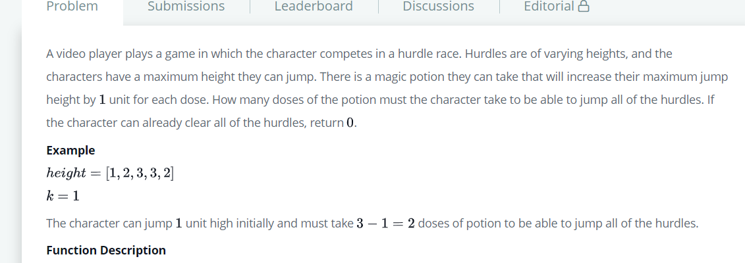

**def** hurdleRace(k, height):

*# Write your code here*

    max_num=**max**(height)

    result_val=max_num-k

    count=0

**if** result_val >0:

        count=result_val

**else**:

        count=0

**return** count